**1. INTRODUCTION**

**1.1 OVERVIEW OF THE SYSTEM**

In this Profile Finder report in php paper, we presented the design and implementation of webpage with which users can get developer related information they need anytime and anywhere. The system provides information query of the developers in different field based on the user’s location. The system is mainly web service and will help to find appropriate developers.

**1.2 PROBLEM DEFINITION AND OBJECTIVE OF THE PROJECT**

The problem definition can be explained as the user’s need for developers for their project . That is the system provides information query of the developers in different field based on the user’s location. The system is mainly web service and will help to find appropriate developers. The application helps you to find your nearby Developers according to their field and location . In this project we also implement messaging system for the communication between them.

**2. SYSTEM ANALYSIS**

* 1. **INTRODUCTION**

System analysis or study is an important phase of any system development process. The system is studied to the minutest details and analyzed. The system analyst plays the role of an interrogator and dwells deep into the working of the present system. The system is viewed as a whole and the inputs to the system are identified. The outputs from the organization are traced to through the various processing that the input phases through in the organization.

A detailed study of this process must be made by various techniques like interviews; questionnaires etc. the data collected by these sources must be scrutinized to arrive to a conclusion. The conclusion is an understanding of the system functions. This system is called existing system. Now the existing system is close study and problem solver tries to sort out difficulties that the enterprise faces.

* 1. **IDENTIFICATION OF NEED**

Our Web Application will allow users and developers to communicate with each other to participate in clients projects. The sophisticated method of finding users location and messaging features allow the easy use of our application. We provide easy to use user interface with functionality.

**2.3** **EXISTING SYSTEM**

In an existing system there are users who contact developers through social media or mutual contacts. This approach of finding appropriate developers is very unsystematic and very time consuming. This approach does not allow new developers in the industry to get exposure to other clients.

Following this type of approach, we may not able to find developers following latest technology and procedures and also the client will be forced to hire developers at a higher price.

* 1. **PROPOSED SYSTEM**

The proposed application helps to find developers easily and quickly. This system helps to overcome this issue by providing developer details in one click. Here the locator allows you to search developers from different locations as well as the current location of user. Admin is allowed to access and manage developer details and user details. This Profile Finder reduces work and can easily find the developers from various location. Reduces your time and cost. The main objective is to provide a broad range of developers for the client for different type of projects and also promote freelancing.

**2.4.1** **BENEFITS OF PROPOSED SYSTEMS**

The main advantage of the proposed system is user convenience. In this system, each module is built in such a way that the user can view and access relevant data. Anyone can go through the system conveniently. Only authorized user can access the search application forms. The system is secured because the authorized users are provides with a unique id and password. Further improvement in the system is maintained by providing validation test at each field and also providing proper messages at each step. This helps in reducing the bugs and also improves the efficiency of the system.

* 1. **FEASIBILITY STUDY**

The feasibility study is carried out to determine whether the proposed system can be developed with available resources. A feasibility study is a test of system proposal according to its workability, ability to meet customer needs, and effective use of resources.

**2.5.1 ECONOMIC FEASIBILITY**

The given system can be developed under optimal expense with the available hardware and software. Besides it is a good economic to invest in such a kind of software from the project manager’s point of view as the benefits overweighs the costs. The resources need to run the above project should be less in cost and highly reliable so that there might be no hanging and minimum level of expense to implement the software. Economic feasibility is the most frequently used method for evaluating the effectiveness of a candidate system. More commonly known cost/benefit analysis the procedure is to determine the benefits and savings that are accepted from a candidate system and compare them with costs.

* + 1. **TECHNICAL FEASIBILITY**

The project requires the system to be functional and multi-user one. It should be based on specified technology. The system understudy must be portable and platform independent. It should be compactable with all kind of existing system in industry and should not provide any overhead to the user. Technical feasibility senders on the existing system and to what extent it can support the proposed system. Updating and viewing the previous editions are tedious in the existing system. Implementation of proposed system does not require saving of the existing configuration of the system.

* + 1. **BEHAVIOURAL FEASIBILITY**

People are inherently resistant to change, and computers have been known to facilitate change. An estimate should be made of how strong a reaction the user staff is likely to have toward the development of a computerized system. It is common knowledge that computer installations have something to do with turnover, transfers, retraining, and changes in employee job status. Therefore, it is understandable that the introduction of a candidate system requires special effort to educate, sell, and train the staff on new ways of conducting business  In our safe deposit example, three employees are more than 50 years old and have been with the bank over 14 years, four years of which have been in safe deposit. The remaining two employees are in their early thirties. They joined safe deposit about two years before the study. Based on data gathered from extensive interviews, the younger employees want the programmable aspects of safe deposit (essentially billing) put on a computer. Two of the three older employees have voiced resistance to the idea. Their view is that billing is no problem. The main emphasis is customer service-personal contacts with customers. The decision in this case was to go ahead and pursue the project.

* + 1. **OPERATIONAL FEASIBILITY**

The present system is easily understandable and maintenance and working of a new system needs less human efforts. The proposed project is beneficial to the organization and is user friendly. The system is directly used by administrator and staff of the courier management system. So the system can be judged operationally feasible.

* + 1. **HARDWARE AND SOFTWARE FEASIBILITY**

Assessing technical feasibility includes evaluating the ability of computer hardware and software to handle workloads adequately. All current computer hardware the organization owns must be inventoried to discover what is on hand and what is usable. The systems analyst needs to work with users to determine what hardware will be needed. Hardware determinations can come only in conjunction with determining human information requirements. Knowledge of the organizational structure and how users interact with technologies in an organizational setting can also be helpful in hardware decisions. Only when systems analysts, users, and management have a good grasp of what kinds of tasks must be accomplished can hardware options be considered.

The development team visits the user and studies their system. They investigate the need for development in the given system. By the end of the feasibility study, the team furnishes a document that holds the different specific recommendations for the candidate system. It also includes the personnel assignments, costs, project schedule and target dates. The requirements-gathering process is intensified and focuses specifically on software. To understand the nature of the program to be built, the System Engineer (developer) must understand the information area for the software, as well as required function, its behaviour, performance and other systems it interfaces with.

* + 1. **LEGAL FEASIBILITY**

Legal feasibility study is to know if the proposed project conform the legal and ethical requirement.  It is important that the project or business is following the requirements needed to start a business or a project including business licenses, certificates, copyrights, business insurance, tax number, health and safety measures, and many more. There are some things to consider in legal feasibility study including ethical issues and some social issues. These issues are the privacy, nepotism, and accountability.

* + 1. **SCHEDULE AND RESOURCE FEASIBILITY**

It is also an essential part of a feasibility study. It includes questions regarding time required to complete the project, type and amount of resources required and dependent factors. It also takes care whether the project is interrupting any current business activity.

A project will fail if it takes too long to be completed before it is useful. Typically this means estimating how long the system will take to develop, and if it can be completed in a given time period using some methods like payback period. Schedule feasibility is a measure of how reasonable the project time table is.

* 1. **SYSTEM SPECIFICATION**

After the analyst has collected all required information regarding the software to be developed, and has removed all completeness, inconsistence, and anomalies from specification, he starts to systematically organize the requirements the form of an SRSdocument**.** The software developers refer to the SRSdocumentto make sure that they developed exactly what the customer requires. The SRS document helps the maintenance engineers to understand the functionality of the system.

**2.6.1 SOFTWARE SPECIFIACTION**

A software requirements specification (SRS) is a description of a software system to be developed. It is modeled after business requirement specification, also known as a stakeholder requirement specification. The software requirements specification lays out functional and non-functional requirements and it may include a set of use cases that describe user interactions that the software must provide to the user for perfect interaction.

Software requirements specification establishes the basis for an agreement between customers and contractors or suppliers on how the software product should function (in a market-driven project, these roles may be played by the marketing and development divisions). Software requirements specification is a rigorous assessment of requirements before the more specific system design stages, and its goal is to reduce later redesign. It should also provide a realistic basis for estimating product costs, risks, and schedules. Used appropriately, software requirements specifications can help prevent software project failure.

The software requirements specification document lists sufficient and necessary requirements for the project development. To derive the requirements, the developer needs to have clear and thorough understanding of the products under development. This is achieved through detailed and continuous communications with the project team and customer throughout the software development process.

* + 1. **TOOLS/PLATFORM**

SUBLIME TEXT 3

It  is an amazing piece of software. To start, it is a clean, functional, and fast code editor. Not only does it have incredible built in features (multi-edit and vim mode), but it has support for plugins, snippets, and many other things.

Sublime Text is a versatile editor for programmers, but you don’t need to be one in order to use it, and you don’t need to configure it extensively to be productive—it’s an efficient tool out of the box. Hackers, however, will appreciate all the customization and extensibility opportunities. Sublime Text exposes its internals via an Application Programming Interface (API) that programmers can interact with using the Python programming language. An embedded Python interpreter is included in the editor. The embedded interpreter is useful to inspect the editor’s settings and to quickly test API calls while developing plugins.

SQLyog

SQLyog is the most powerful manager, admin and GUI tool for MySQL, combining the features of MySQL Query Browser, Administrator, phpMyAdmin and other MySQL Front Ends and MySQL GUI tools in a single intuitive interface. SQLyog is a fast, easy to use and compact graphical tool for managing your MySQL databases. SQLyog was developed for all who use MySQL as their preferred RDBMS. Whether you enjoy the control of handwritten SQL or prefer to work in a visual environment, SQLyog makes it easy for you to get started and provides you with tools to enhance your MySQL experience.

SQLyog allows easy access to frequently used SQL scripts. The script files can be stored as files from the SQLyog interface or link to an existing file anywhere where windows can access it - on a local drive or a shared network drive. The SQL scripts and the file links can be organized in folder and subfolders.

WAMP

Stands for "Windows, Apache, MySQL, and PHP." WAMP is a variation of LAMP for Windows systems and is often installed as a software bundle (Apache, MySQL, and PHP). It is often used for web development and internal testing, but may also be used to serve live websites.

The most important part of the WAMP package is Apache (or "Apache HTTP Server") which is used run the web server within Windows. By running a local Apache web server on a Windows machine, a web developer can test webpages in a web browser without publishing them live on the Internet.

WAMP also includes MySQL and PHP, which are two of the most common technologies used for creating dynamic websites. MySQL is a high-speed database, while PHP is a scripting language that can be used to access data from the database. By installing these two components locally, a developer can build and test a dynamic website before publishing it to a public web server.

While Apache, MySQL, and PHP are open source components that can be installed individually, they are usually installed together. One popular package is called "WampServer," which provides a user-friendly way to install and configure the "AMP" components on Windows.

* + 1. **HARDWARE SPECIFICATION**

Processor : INTEL Core i3

Speed : 2.4 GHz

Memory : 500 GB

Hard Disk : 500 MB free space

Monitor : HP

Keyboard : 102

Operating System : WINDOWS

Front End : HTML,CSS

Back End : PHP,MYSQL

IDE :Sublime text 3,MySQL Server

**3. SYSTEM DESIGN**

**3.1 INTRODUCTION**

System design is an interactive process through which requirement are transmitted to a “blue print” for constructing the software initial; the blue print depicts a holistic view of software that is design is represented at a high-level abstraction a level that can be directly traced to specific data, functional and behavioral requirement. As design interaction occur subsequent refinement leads to design representation at much lower level of abstraction. System design is a creative art of inventing and developing input, data bases, off line files, method and procedures, for processing data to get meaning full output that satisfy the organization objectives. Through the design phase consideration to the human factor, that is inputs to the users will have on the system. Some of the main factors that have to be noted using the design of the system are:

* Practicability

System must be capable of being operated over a long period of time and must have ease of use.

* Efficiency

Make better use of available resources. Efficiency involves accuracy, timeliness and comprehensiveness of system output.

* Cost

Aim of minimum cost and better results.

* Security

Ensure physical security of data.

**3.2 INPUT DESIGN**

Input design is the process of converting user-oriented input to a based format. Inaccurate input data are the most common cause of errors in data processing. Errors entered by data entry operators can be controlled by input design.

The goal of designing input data is to make data entry as easy, logical and free from errors. When we approach input data design; we design the data source documents that capture the data and then select the media used to enter them into computer.

User-friendly screen format can reduce the burden on end users, who are not highly proficient in computers. An important step in input design stage is a design of source document. Source document is the form in which the data can initially capture. The next step is the design of the document layout. In the layout organizes the document by placing information, where it will be noticed and establishes the appropriate sequence of items.

In our system, almost all inputs are being taken from the databases. To avoid adequate inputs we have to select necessary values from the databases and arrange it to the appropriate controls.

**3.3 OUTPUT DESIGN**

Computer output is the most important and direct source of information to the user. Efficient and intelligent output design improves the system’s relationship and helps user decision-making.

In the output design it is determine how the implementation is to be played for immediate need and also the hardcopy output. A major form of input is a hardcopy from the printer. Printouts should be designed around the output requirement of the user. Printers, CRT screen display are the examples for providing computer based output. The output design associated with the system includes the various reports of the table generations and query executions.

Output design is one of the, most important features of the information system. The logical design of an information system is analogous to an engineering blue print of an automobile. It shows the major features and how they are related to one another. The outputs, inputs and databases are designed are in this phase.

**3.4 DATABASE DESIGN**

Database design is one of the most important parts of the system design phase. In a database environment, data available are used by several users instead of each program managing its own data, authorized users share data across application with the database software managing the data as an entity.

Primary key is one of the candidate key that are chosen to be the identifying key for the entire table.

**Normalization** is a process of organizing the data in database to avoid data redundancy, insertion anomaly, update anomaly & deletion anomaly.

Here are the most commonly used normal forms:

* First normal form(1NF)
* Second normal form(2NF)
* Third normal form(3NF)
* Boyce & Codd normal form (BCNF)

FIRST NORMAL FORM(1NF)

As per the rule of first normal form, an attribute (column) of a table cannot hold multiple values. It should hold only atomic values.

SECOND NORMAL FORM(2NF)

A table is said to be in 2NF if both the following conditions hold:

* Table is in 1NF (First normal form)
* No non-prime attribute is dependent on the proper subset of any candidate key of table.

An attribute that is not part of any candidate key is known as non-prime attribute.

THIRD NORMAL FORM(3NF)

A table design is said to be in 3NF if both the following conditions hold:

* Table must be in 2NF
* [Transitive functional dependency](https://beginnersbook.com/2015/04/transitive-dependency-in-dbms/) of non-prime attribute on any super key should be removed.
* An attribute that is not part of any candidate key is known as non-prime attribute.

In other words, 3NF can be explained like this: A table is in 3NF if it is in 2NF and for each functional dependency X-> Y at least one of the following conditions hold:

* X is a super-key of table
* Y is a prime attribute of table
* An attribute that is a part of one of the candidate keys is known as prime attribute.

Boyce Codd normal form (BCNF)

It is an advance version of 3NF that’s why it is also referred as 3.5NF. BCNF is stricter than 3NF. A table complies with BCNF if it is in 3NF and for every functional dependency X->Y, X should be the super key of the table.

* 1. **DATA FLOW DIAGRAM**

A data flow diagram (DFD) is a graphical representation of the "flow" of data through an [information system](https://en.wikipedia.org/wiki/Information_system), modelling its process aspects. A DFD is often used as a preliminary step to create an overview of the system without going into great detail, which can later be elaborated. DFDs can also be used for the [visualization](https://en.wikipedia.org/wiki/Data_visualization) of [data processing](https://en.wikipedia.org/wiki/Data_processing) (structured design).

A DFD shows what kind of information will be input to and output from the system, how the data will advance through the system, and where the data will be stored. It does not show information about process timing or whether processes will operate in sequence or in parallel, unlike a traditional structured [flowchart](https://en.wikipedia.org/wiki/Flowchart) which focuses on control flow, or a UML activity workflow diagram, which presents both control and data, flows as a unified model.

RULES FOR DRAWING DATA FLOW DIAGRAM

* Each process should have at least one input and an output.
* Each data store should have at least one data flow in and one data flow out.
* Data stored in a system must go through a process.
* All processes in a DFD go to another process or a data store.

BASIC DFD SYMBOLS

The primitive symbols used in the DFDA are:

* External entity

The external entities are essentially those physical entities external to the software system which interact with the system by inputting data to the system or by consuming the data produced by the system. For example user of a system, Entities supplying data are known as sources and those that consume data are sinks.

* Process

The functions are using circles. Bubbles are annotated with the names of the corresponding functions. They convert data into information.

* Data Flow

A directed arrow or arc is used as data flow symbol that represents the data flow occurring between two processes, or between external entity and a process.

* Data Store

A data store represents logical files. Each data store is connected to a process by means of data flow symbol.

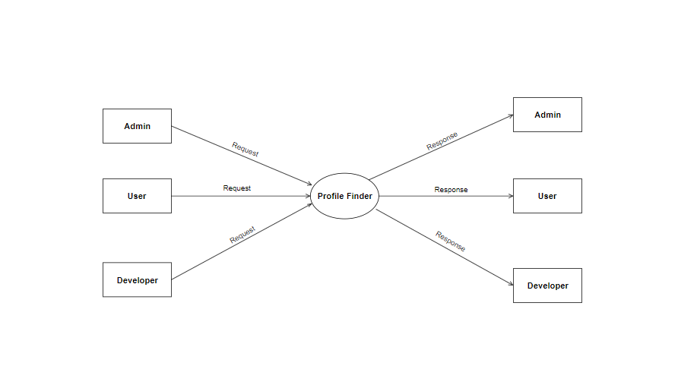

CONTEXT DIAGRAM

LEVEL 1 ADMIN

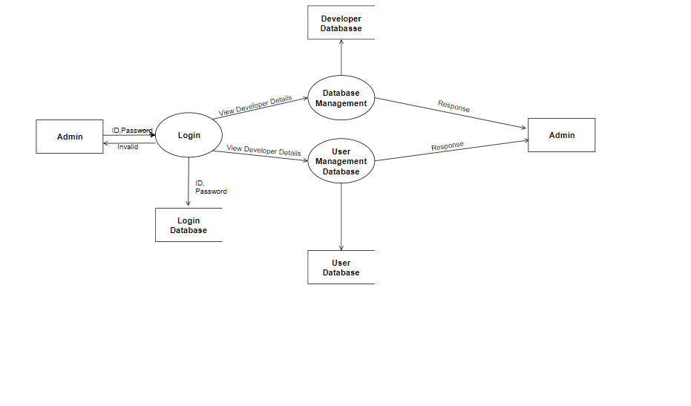

LEVEL 1 USER

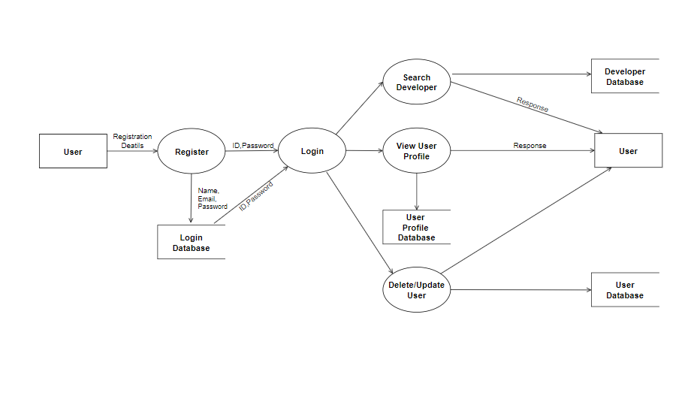

LEVEL 1 DEVELOPER

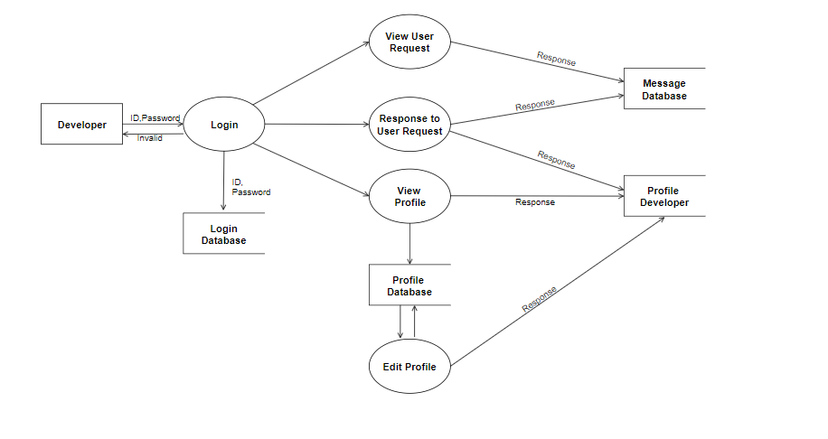

LEVEL 2 USER

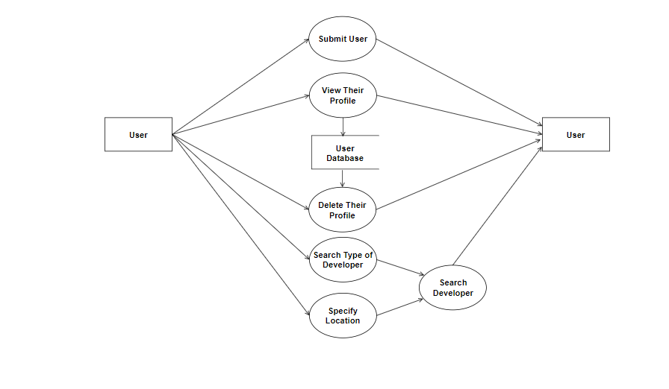

**4. SYSTEM DEVELOPMENT**

**4.1 MOUDLE DESCRIPTION**

Registration Module

Registration module is the first module which allows user to register their details in order gets access of the application. It consist of simple registration form, where the user details such as name, email, password are asked for entering which are stored in database server.

Location Module

It helps the user to select the appropriate location in which the user want the developer. In this module the user can select an area or choose current location of the user. The location of various developers are stored in the database. They can choose from the drop box directly from the webpage interface provided in the application.

Developer Finder Module

This module helps the user to search for a specific type of developer who has expertise in various field of development. This module helps the user to find the appropriate developer for their project

Messaging Module

This module is used for the communication between the developer and the user. This module helps the user to send message to appropriate developer regarding their project and also receive messages from the developers. In this sophisticated messaging module the sender and receiver can send messages as well as replay to the messages. The messaging module is very user friendly and can be used by anyone with various technical skills. The receiving and sending of messages are in real time so there is no delay in communication.

Register as Developer Module

In this module an user themselves can register as a developer by giving details such as their field of expertise, email id, name. This allows the user to advertise themselves as a developer for different client.

**4.2 SOURCE CODE**

INDEX

<?php

session_start();

?>

<!DOCTYPE HTML>

<html lang="zxx">

<head>

<title>PROFILE FINDER</title>

<!-- Meta tag Keywords -->

<meta name="viewport" content="width=device-width, initial-scale=1">

<meta charset="UTF-8" />

<meta name="keywords content="Land Responsive web template, Bootstrap Web Templates, Flat Web Templates, Android Compatible web template, Smartphone Compatible web template, free webdesigns for Nokia, Samsung, LG, SonyEricsson, Motorola web design" />

<script>

addEventListener("load", function () {

setTimeout(hideURLbar, 0);

}, false);

function hideURLbar() {

window.scrollTo(0, 1);

}

</script>

<!-- //Meta tag Keywords -->

<!-- Custom-Files -->

<link href="css/bootstrap.css" rel='stylesheet' type='text/css' />

<!-- Bootstrap-Core-CSS -->

<link href="css/style.css" rel='stylesheet' type='text/css' />

<!-- Style-CSS -->

<link href="css/font-awesome.min.css" rel="stylesheet">

<!-- Font-Awesome-Icons-CSS -->

<!-- //Custom-Files –

<!-- Web-Fonts -->

<link

href="//fonts.googleapis.com/css?family=Roboto+Condensed:300,300i,400,400i,700,700i&amp;subset=cyrillic,cyrillic-ext,greek,greek-ext,latin-ext,vietnamese"

rel="stylesheet">

<link href="//fonts.googleapis.com/css?family=Open+Sans:300,300i,400,400i,600,600i,700,700i,800,800i&amp;subset=cyrillic,cyrillic-ext,greek,greek-ext,latin-ext,vietnamese"

rel="stylesheet">

<!-- //Web-Fonts -->

</head>

<body>

<!-- header -->

<header>

<div class="container">

<div class="header d-lg-flex justify-content-between align-items-center py-2 px-sm-->

<!-- logo -->

<div id="logo">

<h1><a href="index.php"><span class="text-bl">P</span>rofile Finder</a></h1>

</div>

<!-- //logo -->

<!-- nav -->

<div class="nav_w3ls ml-lg-5">

<nav>

<label for="drop" class="toggle">Menu</label>

<input type="checkbox" id="drop" />

<ul class="menu">

<!-- <li>

<!-- First Tier Drop Down -->

<!-- <label for="drop-2" class="toggle toogle-2">Pages <span class="fa fa-angle-down"

aria-hidden="true"></span>

</label>

<a href="#">Pages <span class="fa fa-angle-down" aria-hidden="true"></span></a>

<input type="checkbox" id="drop-2" />

<ul>

<li><a href="#about" class="drop-text">About Us</a></li>

<li><a href="#services" class="drop-text">Services</a></li>

<li><a href="#gallery" class="drop-text">Gallery</a></li>

</ul>

</li>

<li><a href="login.php">Login</a></li>

<li><a href="register.php">Register</a></li>

</ul>

</nav>

</div>

<!-- //nav -->

</div>

</div>

</header>

<!-- //header -->

<!-- banner -->

<div class="main-w3pvt mian-content-wthree text-center" id="home">

<div class="container">

<div class="style-banner mx-auto">

<h3 class="text-wh font-weight-bold">Search and Find Your Ideal <!-- <span>Ideal</span> --> Employee</h3>

<p class="mt-2 text-li" id="find">Locate ideal employee near us</p>

<!-- form -->

<div class="home-form-w3ls mt-5 pt-lg-4">

<form method="post">

<div class="row">

<div class="col-lg-6">

<div class="form-group">

<select required="" class="form-control" name="search">

<option value="">Choose...</option>

<option value="PHP_Developer">PHP Developers</option>

<option value="Web_Developer">Web Developers</option>

<option value="mobile">Mobile Application Developers</option>

<option value="system">System Analyst</option>

</select>

</div>

<!-- <div class="form-group">

<select required="" class="form-control">

<option value="">All Type</option>

<option value="1">Apartments</option>

<option value="2">Restaurant</option>

<option value="3">Shop</option>

<option value="4">Villa</option>

</select>

</div> -->

</div>

<div class="col-lg-6">

<!-- <div class="form-group">

<select required="" class="form-control">

<option value="">Bedrooms</option>

<option value="1">1</option>

<option value="2">2</option>

<option value="3">3</option>

<option value="4">4</option>

</select>

</div> -->

<div class="form-group">

<select required="" class="form-control" name="location">

<option value="">Location</option>

<option value="Currentlocation">Current Location</option>

<option value="Cochin">Cochin</option>

<option value="Alappuzha">Alappuzha</option>

<option value="Trivandrum">Trivandrum</option>

<option value="Calicut">Calicut</option>

<option value="Quilon">Kollam</option>

</select>

</div>

</div>

</div>

<button type="submit" class="btn btn_apt" name="find">Find Here</button>

</form>

</div>

<!-- //form -->

</div>

</div>

</div>

<!-- //banner ======================================php code starts here ===========================-->

<?php

if (isset($_POST["find"]))

{

require_once('connect.php');

if ($_POST['location'] == "Currentlocation")

//$currentlocation = file_get_contents('http://ashokmanojphilip.tk/ip_from_db.php'); //this is used to fetch location from my site

//echo $currentlocation;

//$_SESSION['location'] = $currentlocation;

$ch = curl_init();

// set url

curl_setopt($ch, CURLOPT_URL, "http://ashokmanojphilip.tk/ip_from_db.php");

//return the transfer as a string

curl_setopt($ch, CURLOPT_RETURNTRANSFER, 1);

// $output contains the output string

$currentlocation = curl_exec($ch);

$_SESSION['location'] = $currentlocation;

//echo $_SESSION['location'];

//echo $adminhelp;

//var_dump($_SESSION['location']);

// close curl resource to free up system resources

curl_close($ch);

//echo '<script>window.location="correct_location.php"</script>';

}

else

{

$_SESSION['location'] = $_POST['location'];

}

$_SESSION['search'] = $_POST['search'];

echo '<script>window.location="search_db_new.php"</script>';

}

?>

===========================================================

LOGIN

<?php

session_start();

?>

<!DOCTYPE HTML>

<html lang="zxx">

<head>

<title>Login</title>

<!-- Meta tag Keywords -->

<meta name="viewport" content="width=device-width, initial-scale=1">

<meta charset="UTF-8" />

<meta name="keywords"

content="Land Responsive web template, Bootstrap Web Templates, Flat Web Templates, Android Compatible web template, Smartphone Compatible web template, free webdesigns for Nokia, Samsung, LG, SonyEricsson, Motorola web design" />

<script>

addEventListener("load", function () {

setTimeout(hideURLbar, 0);

}, false);

function hideURLbar() {

window.scrollTo(0, 1);

}

</script>

<!-- //Meta tag Keywords -->

<!-- Custom-Files -->

<link href="css/bootstrap.css" rel='stylesheet' type='text/css' />

<!-- Bootstrap-Core-CSS -->

<link href="css/style.css" rel='stylesheet' type='text/css' />

<!-- Style-CSS -->

<link href="css/font-awesome.min.css" rel="stylesheet">

<!-- Font-Awesome-Icons-CSS -->

<!-- //Custom-Files -->

<!-- Web-Fonts -->

<link

href="//fonts.googleapis.com/css?family=Roboto+Condensed:300,300i,400,400i,700,700i&amp;subset=cyrillic,cyrillic-ext,greek,greek-ext,latin-ext,vietnamese"

rel="stylesheet">

<link href="//fonts.googleapis.com/css?family=Open+Sans:300,300i,400,400i,600,600i,700,700i,800,800i&amp;subset=cyrillic,cyrillic-ext,greek,greek-ext,latin-ext,vietnamese"

rel="stylesheet">

<!-- //Web-Fonts -->

</head>

<body>

<!-- header -->

<header>

<div class="container">

<div class="header d-lg-flex justify-content-between align-items-center py-2 px-sm-2>

<!-- logo -->

<div id="logo">

<h1><a href="index.php"><span class="text-bl">P</span>rofile Finder</a></h1>

</div>

<!-- //logo -->

<!-- nav -->

<div class="nav_w3ls ml-lg-5">

<nav>

<label for="drop" class="toggle">Menu</label>

<input type="checkbox" id="drop" />

<ul class="menu">

<li>

<!-- First Tier Drop Down -->

<!-- <label for="drop-2" class="toggle toogle-2">Pages <span class="fa fa-angle-down"

aria-hidden="true"></span>

</label>

<a href="#">Pages <span class="fa fa-angle-down" aria-hidden="true"></span></a>

<input type="checkbox" id="drop-2" />

<ul>

<li><a href="index.html" class="drop-text">About Us</a></li>

<li><a href="index.html" class="drop-text">Services</a></li>

<li><a href="index.html" class="drop-text">Gallery</a></li>

</ul>

</li> -->

<li><a href="index.php">Home</a></li>

<li><a href="register.php">Register</a></li>

</ul>

</nav>

</div>

<!-- //nav -->

</div>

</div>

</header>

<!-- //header -->

<!-- inner banner -->

<div class="inner-banner-w3ls py-5" id="home">

<div class="container py-xl-5 py-lg-3">

<!-- login -->

<div class="modal-body my-5 pt-4">

<h3 class="title-w3 mb-5 text-center text-wh font-weight-bold">Login Now</h3>

<form method="post">

<div class="form-group">

<label class="col-form-label">Username</label>

<input type="text" class="form-control" placeholder="Username" name="Name" required="">

</div>

<div class="form-group">

<label class="col-form-label">Password</label>

<input type="password" class="form-control" placeholder="*****" name="Pass" required="">

</div>

<button type="submit" class="btn button-style-w3" name="btn">Login</button>

<div class="row sub-w3l mt-3 mb-5">

<div class="col-sm-6 sub-w3layouts_hub">

<!-- <input type="checkbox" id="brand1" value=""> -->

<label for="brand1" class="text-li text-style-w3ls">

<!-- <span></span>Remember me?</label> -->

</div>

<div class="col-sm-6 forgot-w3l text-sm-right">

<!-- <a href="#" class="text-li text-style-w3ls">Forgot Password?</a> -->

</div>

</div>

<p class="text-center dont-do text-style-w3ls text-li">Don't have an account?

<a href="register.php" class="font-weight-bold text-li">

Register Now</a>

</p>

</form>

</div>

<!-- //login -->

</div>

</div>

<?php

if (isset($_POST["btn"]))

{

require_once('connect.php');

/////remobe back slash

$username = stripslashes($_POST['Name']);

///remove special characters $con values are in connect.php

$username = mysqli_real_escape_string($con,$username);

$password = stripslashes($_POST['Pass']);

$password = mysqli_real_escape_string($con,$password);

$query = "SELECT * FROM `users` WHERE username='$username' and password='".md5($password)."'";

$retrn = mysqli_query($con,$query);

$rows = mysqli_num_rows($retrn);

if($rows==1)

{

$_SESSION['username'] = $username;

$_SESSION['user_pass'] = md5($password);

// echo $_SESSION['user_pass'];

echo '<script>window.location="user_logged.php"</script>'; //redirect user using

}

else

{

echo '<script>alert("Username and/or password incorrect")</script>';

echo '<script>window.location="login.php"</script>'; //redirect user using js

}

?>

CONNECT

<?php

$server = 'localhost';

$user = 'root';

$dbname = 'profile_finder';

$passwd = '';

$home_url = 'http://localhost:8080/PROJECT_ASHOK/';

$con = mysqli_connect($server,$user,$passwd,$dbname);

if (!$con)

{

echo "<br>";

echo "Connection Failed";

}

else

{

//echo "Connection success";

}

if (isset($_SESSION['username']))

{

$username = $_SESSION['username'];

$query = "SELECT * FROM `users` WHERE username='$username'";

$retrn = mysqli_query($con,$query);

$row = mysqli_fetch_assoc($retrn);

$_SESSION['userid'] = $row['id'];

}

?>

SEND_PM

<?php

session_start();

include('connect.php');

?>

<!DOCTYPE html PUBLIC "-//W3C//DTD XHTML 1.0 Transitional//EN" "http://www.w3.org/TR/xhtml1/DTD/xhtml1-transitional.dtd">

<html xmlns="http://www.w3.org/1999/xhtml">

<head>

<meta http-equiv="Content-Type" content="text/html; charset=utf-8" />

<link href="css/bootstrap.css" rel='stylesheet' type='text/css' />

<link href="css/style.css" rel='stylesheet' type='text/css' />

<link href="css/font-awesome.min.css" rel="stylesheet">

<!-- <link href="<?php echo $design; ?>/style.css" rel="stylesheet" title="Style" /> -->

<title>New PM</title>

</head>

<body>

<div class="header">

<!-- <a href="<?php echo $url_home; ?>"><img src="<?php echo $design; ?>/images/logo.png" alt="Members Area" /></a> -->

</div>

<?php

//We check if the user is logged

if(isset($_SESSION['username']))

{

$form = true;

$otitle = '';

$orecip = '';

$omessage = '';

$id = $_GET['id'];

$query = "SELECT * FROM details_test WHERE id='$id'";

$retrn = mysqli_query($con,$query);

$rows = mysqli_num_rows($retrn);

$row = mysqli_fetch_assoc($retrn);

$name = $row['name'];

//We check if the form has been sent

if(isset($_POST['title'], $_POST['recip'], $_POST['message']))

{

$otitle = $_POST['title'];

$orecip = $_POST['recip'];

$omessage = $_POST['message'];

//We remove slashes depending on the configuration

if(get_magic_quotes_gpc())

{

$otitle = stripslashes($otitle);

$orecip = stripslashes($orecip);

$omessage = stripslashes($omessage);

}

//We check if all the fields are filled

if($_POST['title']!='' and $_POST['recip']!='' and $_POST['message']!='')

{

//We protect the variables

$title = mysqli_real_escape_string($con,$otitle);

$recip = mysqli_real_escape_string($con,$orecip);

$message = mysqli_real_escape_string($con,nl2br(htmlentities($omessage, ENT_QUOTES, 'UTF-8')));

//We check if the recipient exists

$query = 'SELECT count(id) as recip, id as recipid, (select count(*) from pm) as npm from users where username="'.$recip.'"';

$dn1 = mysqli_fetch_array(mysqli_query($con,$query));

if($dn1['recip']==1)

{

//We check if the recipient is not the actual user

if($dn1['recipid']!=$_SESSION['userid'])

{

$id = $dn1['npm']+1;

//We send the message

// $query = 'INSERT into pm (id, id2, title, user1, user2, message, timestamp, user1read, user2read)values("'.$id.'", "1", "'.$title.'", "'.$_SESSION['userid'].'", "'.$dn1['recipid'].'", "'.$message.'", "'.time().'", "yes", "no")';

$userid = $_SESSION['userid'];

$recipid = $dn1['recipid'];

// $query = 'INSERT into pm (id, id2, title, user1, user2, message, timestam,user1read, user2read)values("$id","1","$title","$userid","$recipid","$message","time","yes","no")';

$query = "INSERT into pm (id, id2, title, user1, user2, message, timestam, user1read, user2read)values('$id','1','$title','$userid','$recipid','$message','time','yes','no')";

// echo $id;

// echo '<br>';

// echo $title;

// echo '<br>';

// echo $userid;

// echo '<br>';

// echo $recipid;

// echo '<br>';

// echo $message;

// echo '<br>';

if(mysqli_query($con,$query))

{

$form = false;

}

else

{

//Otherwise, we say that an error occured

$error = 'An error occurred while sending the message';

}

}

else

{

//Otherwise, we say the user cannot send a message to himself

$error = 'You cannot send a message to yourself.';

}

}

else

{

//Otherwise, we say the recipient does not exists

$error = 'The recipient does not exists.';

}

}

else

{

//Otherwise, we say a field is empty

$error = 'A field is empty. Please fill of the fields.';

}

}

elseif(isset($_GET['recip']))

{

//We get the username for the recipient if available

$orecip = $_GET['recip'];

}

if($form)

{

//We display a message if necessary

if(isset($error))

{

$_SESSION['error'] = $error;

echo '<div class="message">'.$error.'</div>';

}

//We display the form

?>

<?php include('header.php'); ?>

<div class="content">

<h1>New Personnal Message</h1>

<form action="new_pm.php" method="post">

Please fill the following form to send a personnal message.<br />

<label for="title">Title</label><input type="text" value="<?php echo htmlentities($otitle, ENT_QUOTES, 'UTF-8'); ?>" id="title" name="title" /><br />

<label for="recip">To<span class="small"></span></label><input type="text" value="<?php echo $name ?>" id="recip" name="recip" /><br />

<label for="message"></label><textarea placeholder="Message" cols="40" rows="5" id="message" name="message"><?php echo htmlentities($omessage, ENT_QUOTES, 'UTF-8'); ?></textarea><br />

<input type="submit" value="Send" name="btn" />

</form>

</div>

<?php

}

}

else

{

echo '<div class="message">You must be logged to access this page.</div>';

}

?>

<!-- <?php

// $error = $_SESSION['error'];

// if (isset($_POST['btn']) and is_null($_SESSION['error']))

// {

// echo '<script>alert("Message Send Successfully")</script>';

// echo '<script>window.location="list_pm.php"</script>';

// }

?> -->

<div class="foot"><a href="list_pm.php">Go to my personnal messages</a>

</div>

</body>

</html>

REGISTER

<!DOCTYPE HTML>

<html lang="zxx">

<head>

<script>

addEventListener("load", function () {

setTimeout(hideURLbar, 0);

}, false);

function hideURLbar() {

window.scrollTo(0, 1);

}

</script>

<!-- //Meta tag Keywords -->

<!-- Custom-Files -->

<link href="css/bootstrap.css" rel='stylesheet' type='text/css' />

<!-- Bootstrap-Core-CSS -->

<link href="css/style.css" rel='stylesheet' type='text/css' />

<!-- Style-CSS -->

<link href="css/font-awesome.min.css" rel="stylesheet">

<!-- Font-Awesome-Icons-CSS -->

<!-- //Custom-Files -->

<!-- Web-Fonts -->

<link href="//fonts.googleapis.com/css?family=Roboto+Condensed:300,300i,400,400i,700,700i&amp;subset=cyrillic,cyrillic-ext,greek,greek-ext,latin-ext,vietnamese"

rel="stylesheet">

<link

href="//fonts.googleapis.com/css?family=Open+Sans:300,300i,400,400i,600,600i,700,700i,800,800i&amp;subset=cyrillic,cyrillic-ext,greek,greek-ext,latin-ext,vietnamese"

rel="stylesheet">

<!-- //Web-Fonts -->

</head>

<body>

<!-- header -->

<header>

<div class="container">

<div class="header d-lg-flex justify-content-between align-items-center py-2 px-sm-21">

<!-- logo -->

<div id="logo">

<h1><a href="index.php"><span class="text-bl">P</span>rofile Finder</a></h1>

</div>

<!-- //logo -->

<!-- nav -->

<div class="nav_w3ls ml-lg-5">

<nav>

<ul class="menu">

<li><a href="index.php">Home</a></li>

<li>

<a href="#">Pages <span class="fa fa-angle-down" aria-hidden="true"></span></a>

<input type="checkbox" id="drop-2" />

<ul>

<li><a href="index.html" class="drop-text">About Us</a></li>

<li><a href="index.html" class="drop-text">Services</a></li>

<li><a href="index.html" class="drop-text">Gallery</a></li>

</ul>

</li> -->

<li><a href="login.php">Login</a></li>

<li><a href="register.php">Register</a></li>

</ul>

<?php

if (isset($_POST["btn"]))

{

require_once('connect.php');

$username = stripslashes($_REQUEST['Name']);

$username = mysqli_real_escape_string($con,$username);

$email = stripslashes($_REQUEST['email']);

$email = mysqli_real_escape_string($con,$email);

$password = stripslashes($_REQUEST['Pass']);

$password = mysqli_real_escape_string($con,$password);

$conform_password = stripslashes($_REQUEST['Conform_Pass']);

$password = mysqli_real_escape_string($con,$password);

$conform_password = mysqli_real_escape_string($con,$conform_password);

$query = "SELECT * FROM `users` WHERE username='$username'";

$retrn = mysqli_query($con,$query);

$rows = mysqli_num_rows($retrn);

if($rows==1)

{

echo '<script>alert("Username Already Registered")</script>';

}

else

{

if ($password == $conform_password)

{

$query = "INSERT into `users` (username, password, email)

VALUES ('$username', '".md5($password)."', '$email')";

$result = mysqli_query($con,$query);

if($result)

{

echo '<script>alert("User Registered successfully")</script>';

echo '<script>window.location="user_logged.php"</script>';

}

}

else

{

echo '<script>alert("Password do not match")</script>';

}

}

?>

**5. SYSTEM IMPLEMENTATION**

**5.1 TESTING**

System testing is a critical aspect of Software Quality Assurance and represents ultimate view of specification, design and coding. Testing is a process of executing a program with the intent of finding an error a good test is one that has a probability of finding an as yet undiscovered error. The process of testing is to identify and correct bugs in the developed system. Nothing is complete without testing. Testing is the vital to the success of the system.

In the code testing the logic of the developed system is tested. For this every module of program is executed to find an error. To perform specification test, the examination of the specifications starting what the program should do and how it should perform under various conditions.

Unit testing focuses first on the modules in the proposed system to locate errors. This enables from the interaction between modules are initially avoided. In unit testing step each module has to be checked separately.

Testing and validation are the most important steps after the implementation the developed system. The system testing is performed to ensure that there are no errors in the implemented system. The software must be executed several times in order to find out the errors in the different modules of the system.

Validation refers to the process of using the new software for the developed system in a live environment that is, new software inside the organization, in order to find out the errors. The validation phase reveals the failures and the buds in the developed system. It will become to known about the practical difficulties the system faces when the operated in the true environment. By testing code of the implemented software, the logical of the program can be examined.

Unit Testing

A unit correspondence to a screen/form in the package. Unit testing focuses on the verification of the corresponding class / screen. This testing includes testing of control paths, interfaces, local and data structures, logical decision, boundary conditions and error handling.

Integration Testing

Integration testing is used to verify the combining of the software modules. Integration testing addresses the issue associated with the dual problem of verification and program construction. System testing used to verify, whether the developed system meets the requirements.

**5.2 VALIDATION CHECK**

Validation is the process, whether we are building the right product i.e., to validate the product which we have developed is right or not. Activities involved in this is Testing the software application In simple words, Validation is to validate the actual and expected output of the software The process of evaluating software during or at the end of the development process to determine whether it satisfies specified requirements It’s a High-Level Activity. Validation is a dynamic process of testing the real product.

Validation is intended to ensure a product, service, or system (or portion thereof, or set thereof) results in a product, service, or system (or portion thereof, or set thereof) that meets the operational needs of the user. For a new development flow or verification flow, validation procedures may involve modeling either flow and using simulations to predict faults or gaps that might lead to invalid or incomplete verification or development of a product, service, or system (or portion thereof, or set thereof). A set of validation requirements (as defined by the user), specifications, and regulations may then be used as a basis for qualifying a development flow or verification flow for a product, service, or system (or portion thereof, or set thereof). Additional validation procedures also include those that are designed specifically to ensure that modifications made to an existing qualified development flow or verification flow will have the effect of producing a product, service, or system (or portion thereof, or set thereof) that meets the initial design requirements, specifications, and regulations; these validations help to keep the flow qualified. It is a process of establishing evidence that provides a high degree of assurance that a product, service, or system accomplishes its intended requirements. This often involves acceptance of fitness for purpose with end users and other product stakeholders. This is often an external process.

**5.3 SYSTEM IMPLEMENTATION**

The implementation is the final state and it is an important phase. It involves the individual programming; system testing, user training and the operational running of developed proposed system that constitutes the application subsystems. A major task of preparing for implementation is education of users, which should really have been taken place much earlier in the project when they were being involved in the investigation and design work. During the implementation phase system actually takes physical shape. In order to develop a system implemented planning is very essential.

The implementation phase of the software development is concerned with translating design specification into source code. The user tests the developed system and changes are made according to their needs. Our system has been successfully implemented. Before implementation several tests have been conducted to ensure that no errors are encountered during the operation. The implementation phase ends with an evaluation of the system after placing into the operation for a period of time.

The process of putting the developed system in actual use is called system implementation. This includes all those activities that take place to convert from old system to new system. The system can be implemented only after testing is done and is found to be working to specifications. The implementation stage is a systems project in its own right. The implementation stage involves following tasks:

1 Careful planning.

2 Investigation of system and constraints.

3 Design of method to achieve change over.

4 Evaluation of the changeover method.

**5.4 SECURITY**

As technology advances, application environment become more complex and application development security becomes more challenging. Applications, systems, and networks are constantly under various security attacks such as malicious code or denial of service. Some of the challenges from the application development security point of view include Viruses, Trojan horses, Logic bombs, Worms, Agents, and Applets

Applications can contain security vulnerabilities that may be introduced by software engineers either intentionally or carelessly.Software, environmental, and hardware controls are required although they cannot prevent problems created from poor programming practice. Using limit and sequence checks to validate users’ input will improve the quality of data. Even though programmers may follow best practices, an application can still fail due to unpredictable conditions and therefore should handle unexpected failures successfully by first logging all the information it can capture in preparation for auditing. As security increases, so does the relative cost and administrative overhead.

Applications are typically developed using high-level programming languages which in themselves can have security implications. The core activities essential to the software development process to produce secure applications and systems include: conceptual definition, functional requirements, control specification, design review, code review and walk-through, system test review, and maintenance and change management.

**6. SYSTEM MAINTAINANCE AND FUTURE ENHANCEMENTS**

**6.1 SYSTEM MAINTAINANCE**

Software maintenance is the modification of a software product after delivery to correct faults, to improve performance or other attributes. Maintenance is the ease with which a program can be corrected if any error is encountered, adapted if its environment changes or enhanced if the customer desires a change in requirement. Maintenance follows conversation to extend that changes are necessary to maintain satisfactory operations relative to changes in the user’s environment. Maintenance often includes minor enhancements or corrections to problems that surface in the system’s operation. Maintenance is also done based on fixing the problems reported, changing the interface with other software or hardware enhancing the software.

**6.2 FUTURE ENHANCEMENTS**

The Profile Finder webpage was developed with the aim of providing the necessary developer for various projects and need of the client. The application is designed to enhance the user experience and ensure that users get immediate and hassle-free results. Our application shall make all possible efforts to locate the necessary developers in the location, provided by the user.

Oru application can be used to locate and communicate with the appropriate developers that are necessary for the users projects. Our sophisticated messaging module allows the user to communicate with the developers of various expertise without any hassle with easy to operate user interface. With the help of complex and sophisticated methods of finding the users current location our application will find the needed developer for the users projects. Our web application works on the bases of latest technology and methods which will provide the user hassle free experience and surely use this application on daily basis.

The Profile finder will surely allow the users to find needed developers with various expertise appropriate for the project. Our application will also allow the freelance workers to find a broad range of clients and improve their business. By using our application we ensure that users and developers will have a hassle free way to communicate with each other.

This research is an attempt provides undeniable assistance to the users or clients who are in need of developers in various field or their project.

Even though there exist a webpage similar to us known or unknown we don’t think it’s the same service. currently we work inside our hometown but soon its going to be global. The application is very useful and easy to use.

Our web application will surely able to help the freelance worker to get better business and connect with new clients and also improve their brand in the industry. Our application is a new way to connect developers with client. It is also have easy to use user interface which allows users of various technical skills to operate with ease.

**7. APPENDIX**

**7.1 TABLE DESIGN**

**7.1.1 Table name: Users**

|  |  |  |  |
| --- | --- | --- | --- |
| **FIELD NAME** | **DATA TYPE** | **DESCRIPTION** | **CONSTRAINTS** |
| id | int | User ID | Primary Key |
| username | varchar(100) | User Name |  |
| password | varchar(100) | User Password |  |
| email | varchar(100) | User Email |  |
| is_reg | int | Check Register |  |

**7.1.2 Table name: Private Message**

|  |  |  |  |
| --- | --- | --- | --- |
| **FIELD NAME** | **DATA TYPE** | **DESCRIPTION** | **CONSTRAINTS** |
| id | int | User ID | Primary Key |
| id2 | int | Recipient ID |  |
| title | varchar(100) | Message Title |  |
| user1 | int | User Name |  |
| user2 | int | Recipient Name |  |
| message | varchar(100) | Message |  |
| user1read | varchar(10) | User Read |  |
| user2read | varchar(10) | Recipient Read |  |

**7.1.3 Table name: Developers Details**

|  |  |  |  |
| --- | --- | --- | --- |
| **FIELD NAME** | **DATA TYPE** | **DESCRIPTION** | **CONSTRAINTS** |
| id | int | Identify | Primary Key |
| Name | varchar(100) | Developer Name |  |
| Firstname | varchar(100) | First Name |  |
| Lastname | varchar(100) | Last Name |  |
| Past Job | varchar(100) | Developer Past Job |  |
| Location | varchar(100) | Developer Location |  |
| Category | varchar(100) | Expertise |  |
| Current Job | varchar(100) | Current Job |  |
| Job | varchar(100) | Job Title |  |

**7.1.4 Table name: City**

|  |  |  |  |
| --- | --- | --- | --- |
| **FIELD NAME** | **DATA TYPE** | **DESCRIPTION** | **CONSTRAINTS** |
| id | int | id | Primary Key |
| geoname_id | int | location identify | Foreign Key |
| city_name | varchar(100) | city name |  |

**7.1.5 Table name: IP**

|  |  |  |  |
| --- | --- | --- | --- |
| **FIELD NAME** | **DATA TYPE** | **DESCRIPTION** | **CONSTRAINTS** |
| geoname_id | int | location identify | Primary Key |
| network | int | network identify |  |

**7.1.6 Table name: Location**

|  |  |  |  |
| --- | --- | --- | --- |
| **FIELD NAME** | **DATA TYPE** | **DESCRIPTION** | **CONSTRAINTS** |
| id | int | identify | Primary Key |
| location | varchar(100) | location |  |

**7.1.7 Table name: Category**

|  |  |  |  |
| --- | --- | --- | --- |
| **FIELD NAME** | **DATA TYPE** | **DESCRIPTION** | **CONSTRAINTS** |
| id | int | identify | Primary Key |
| category | varchar(100) | Dev category |  |

**7.2 SAMPLE INPUT**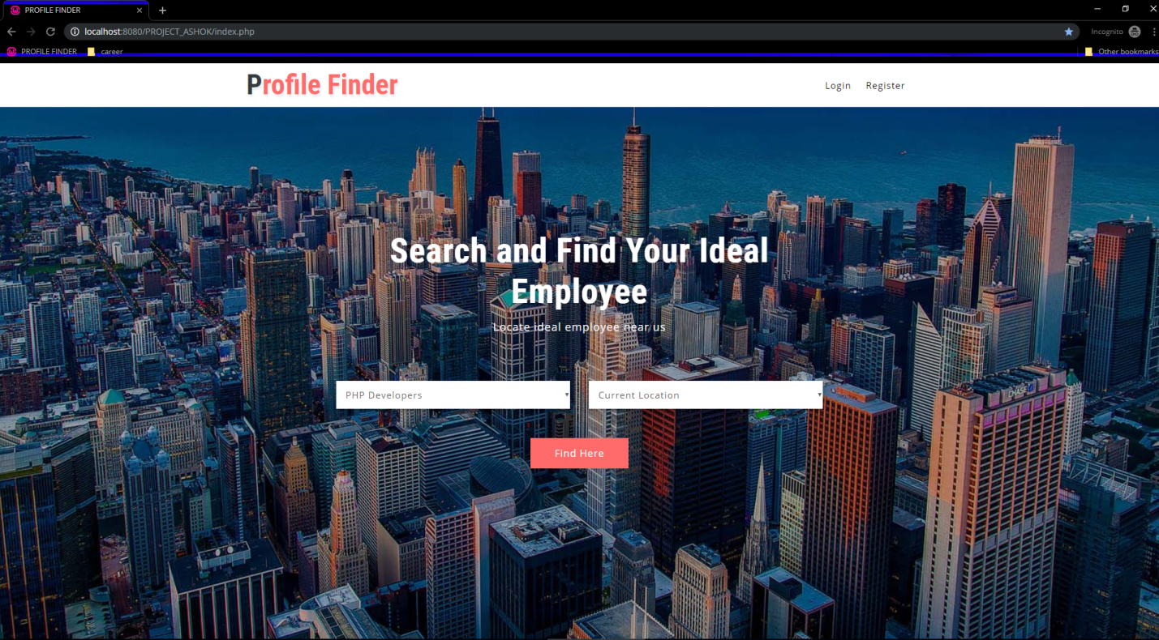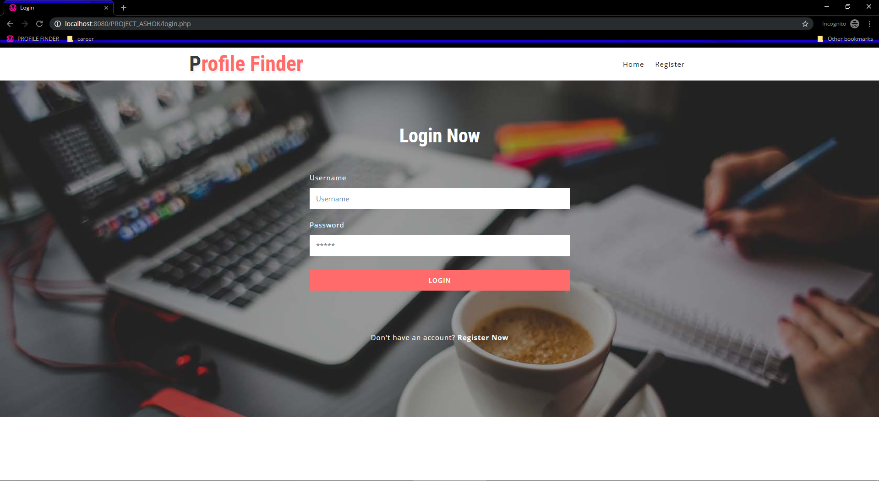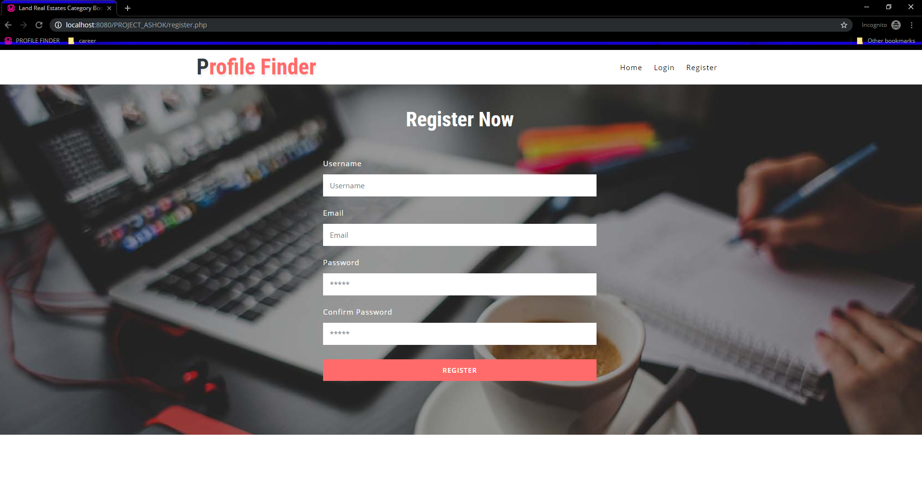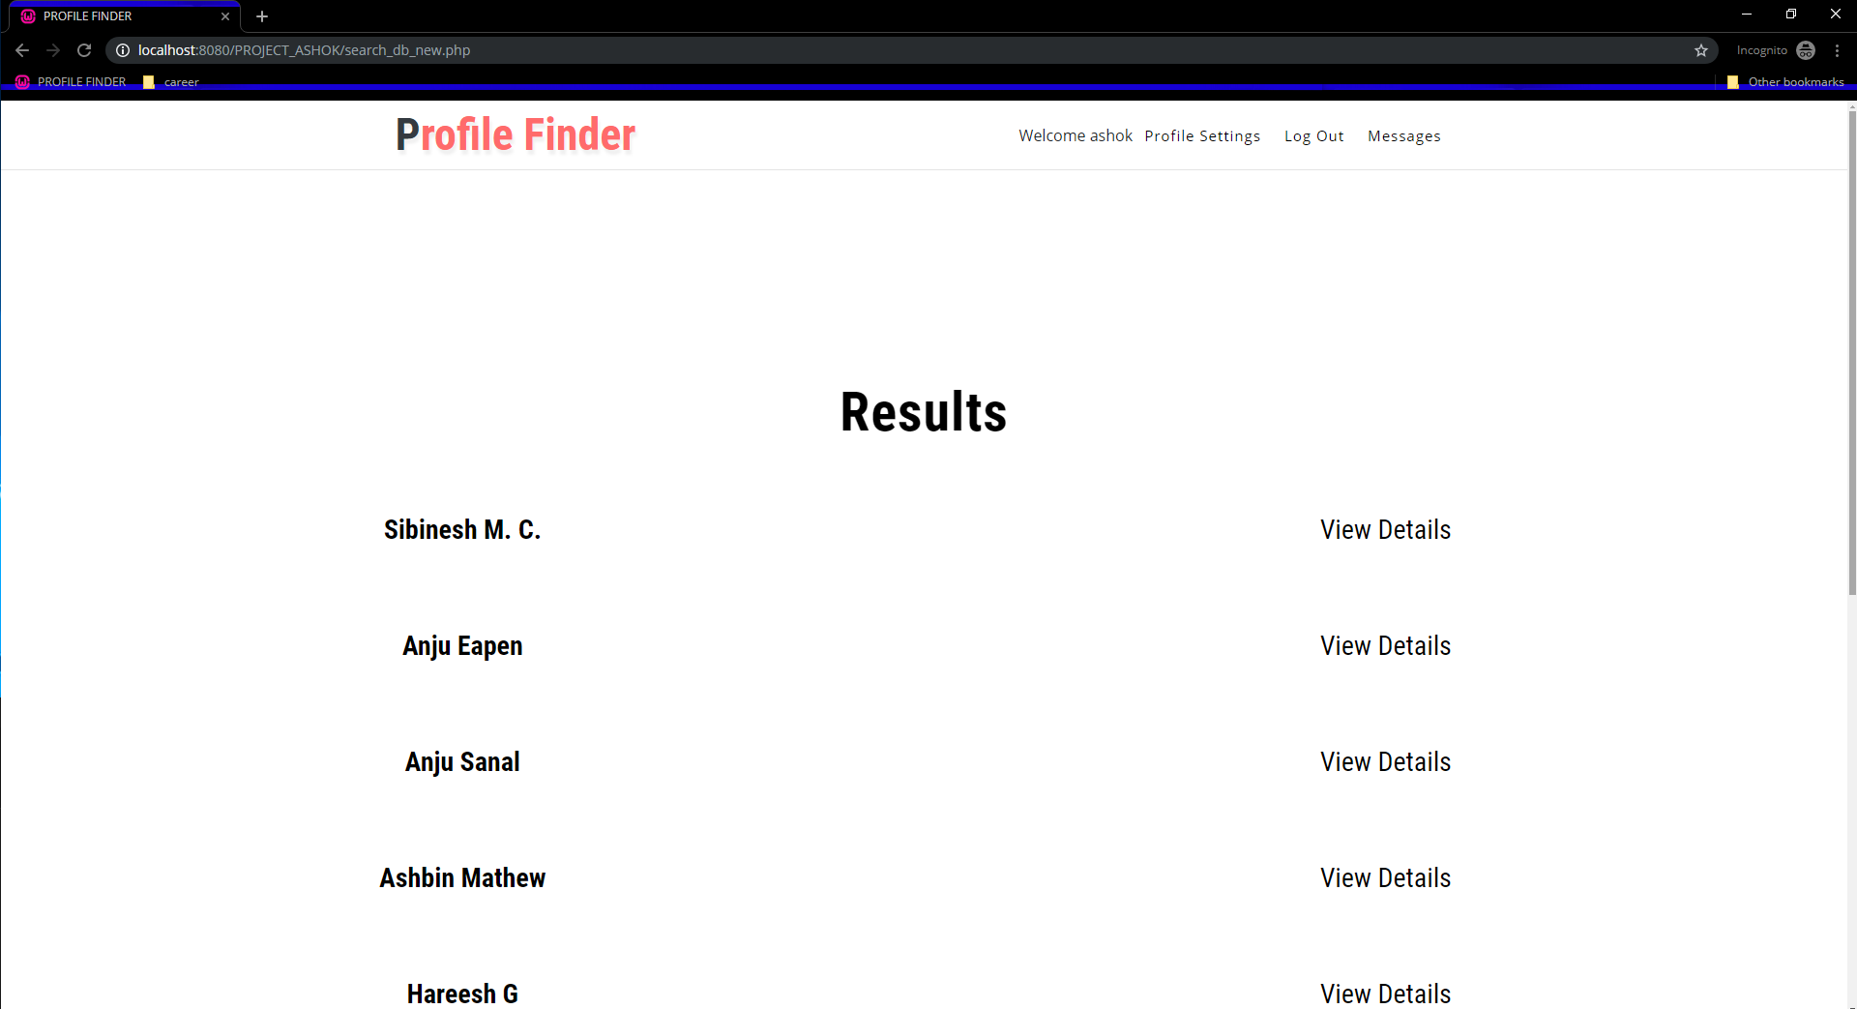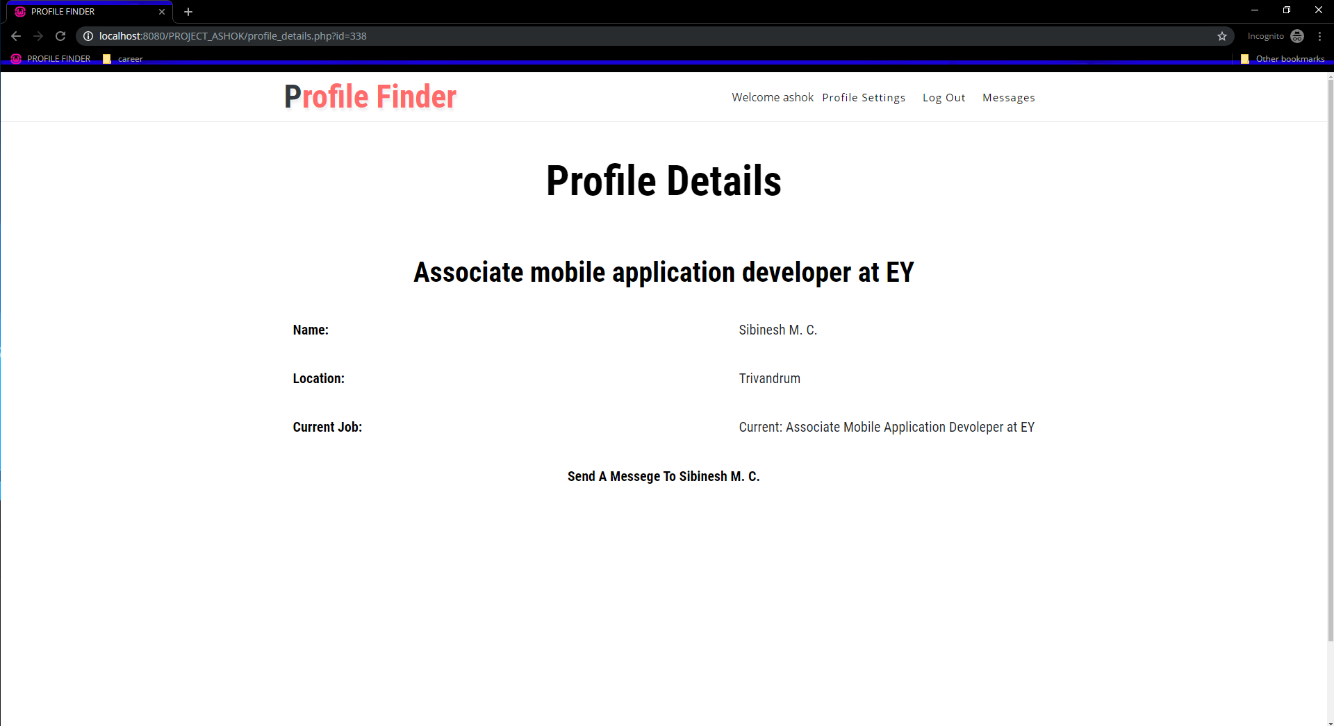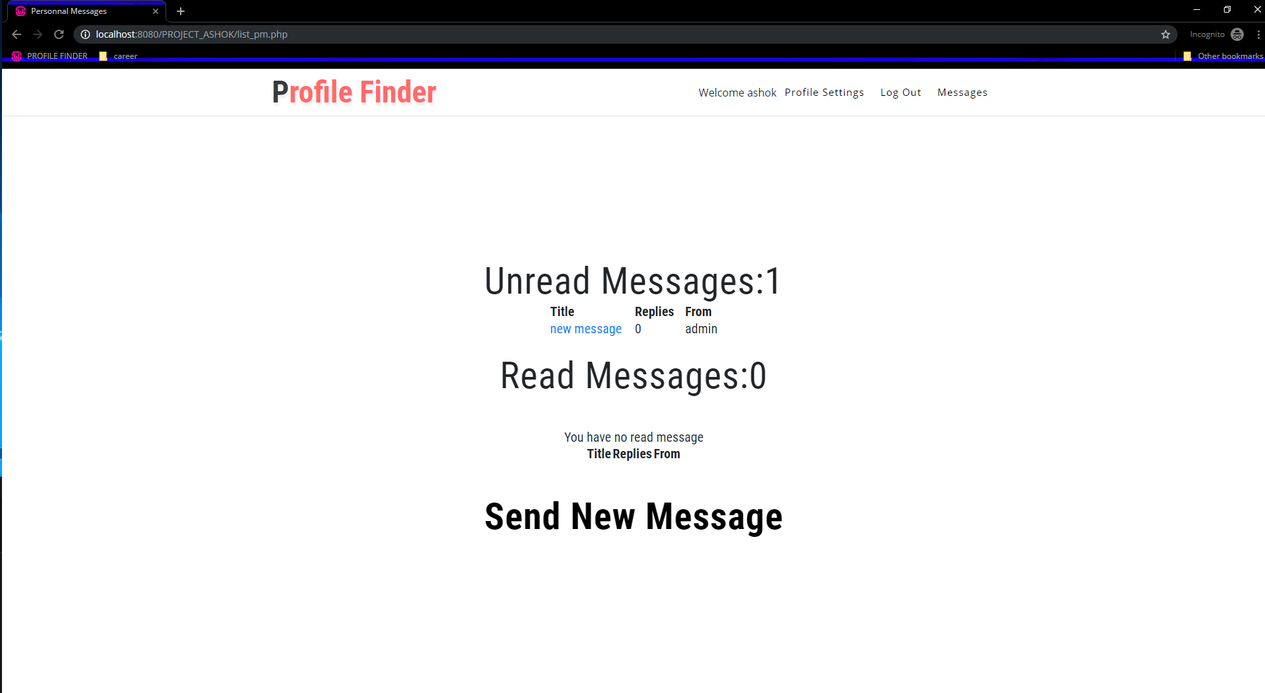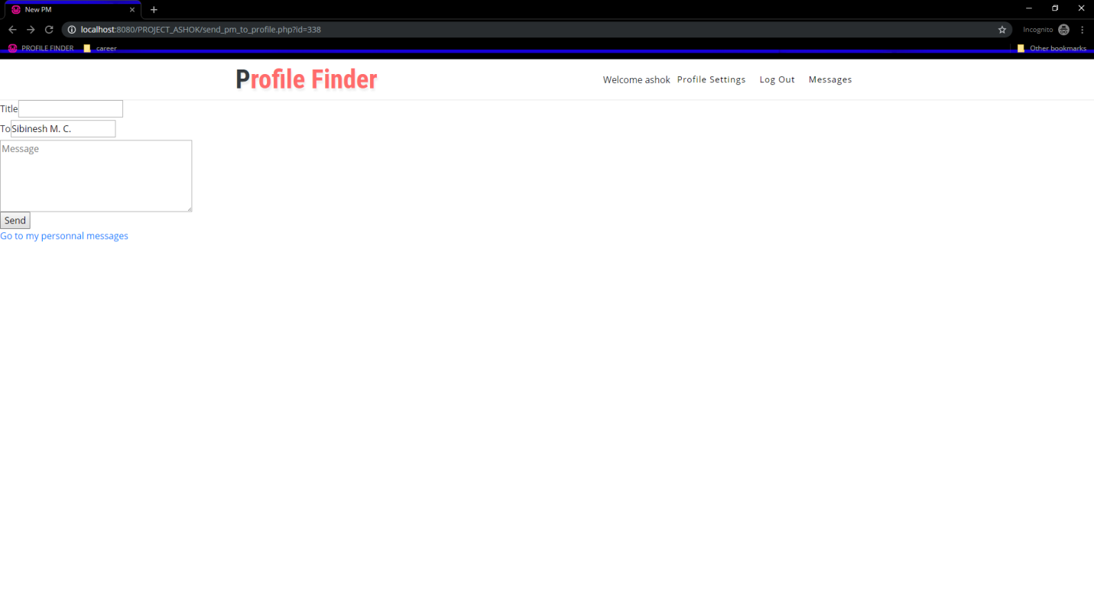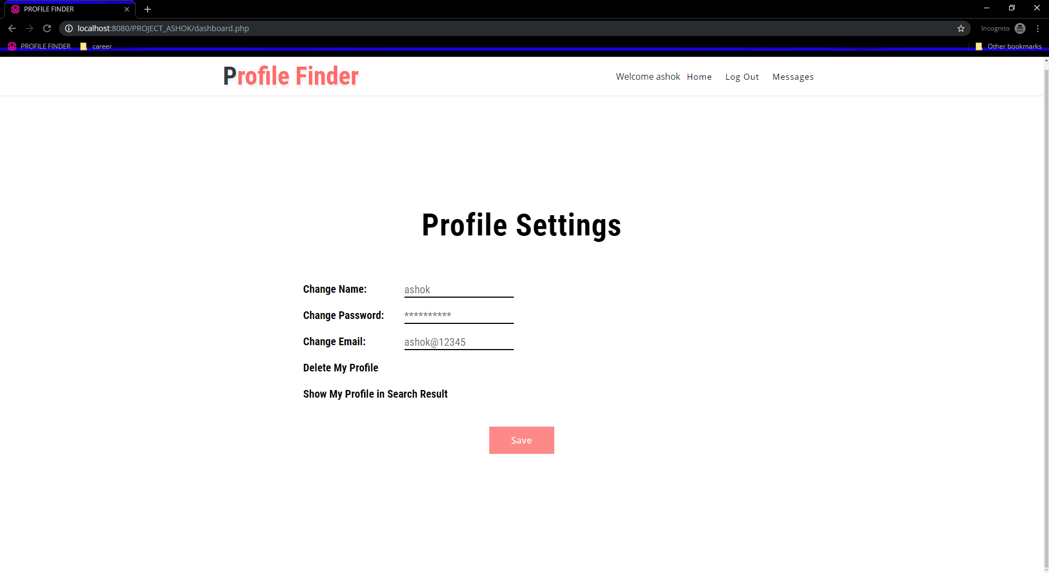

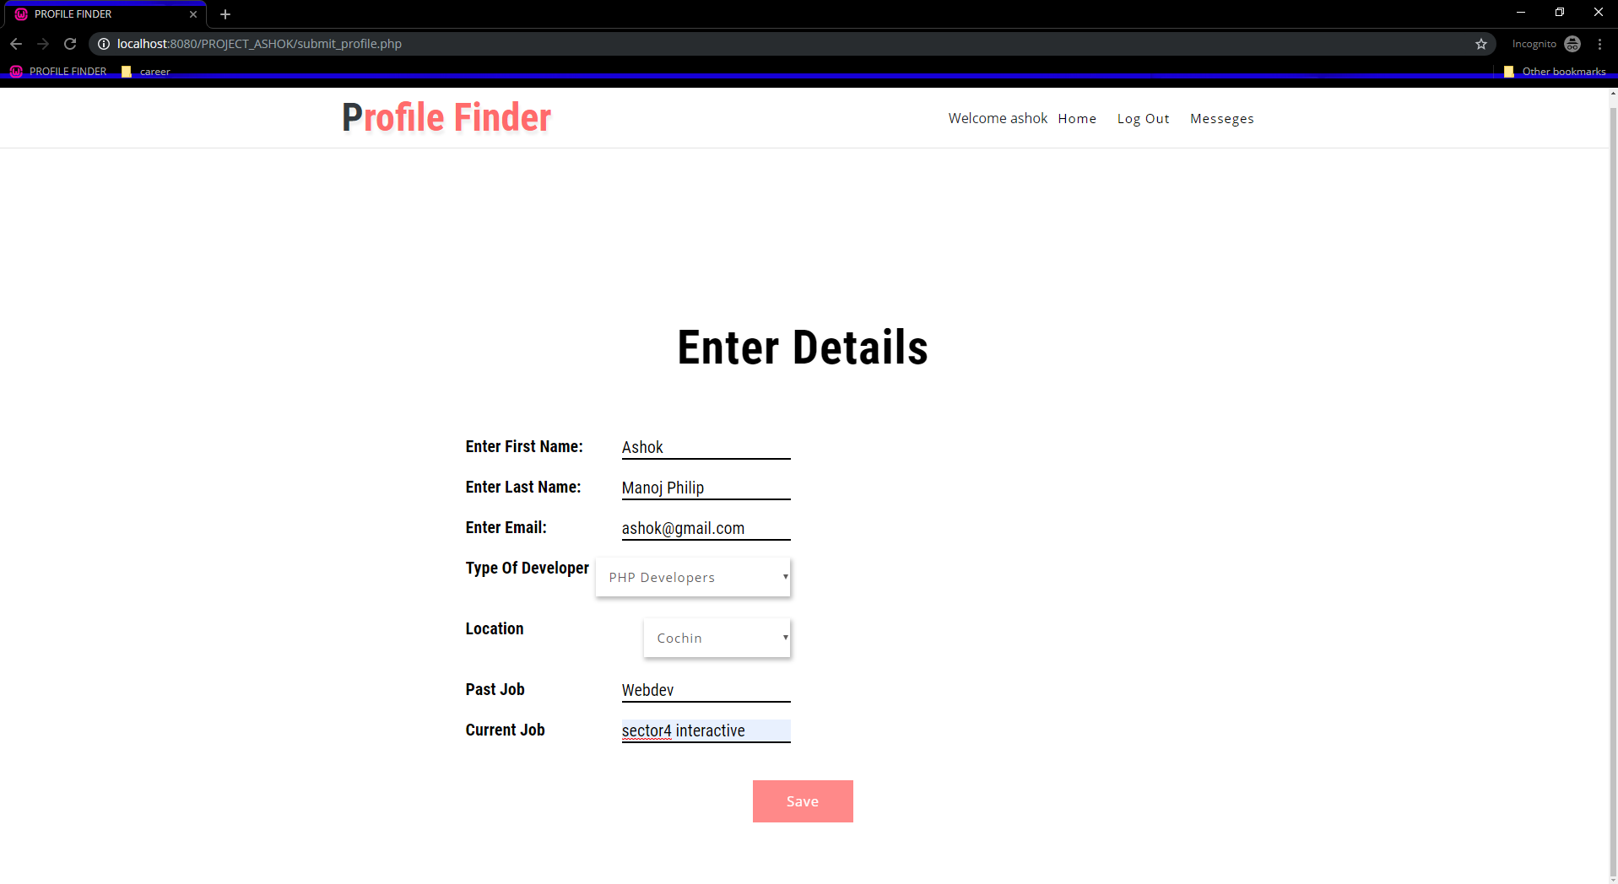

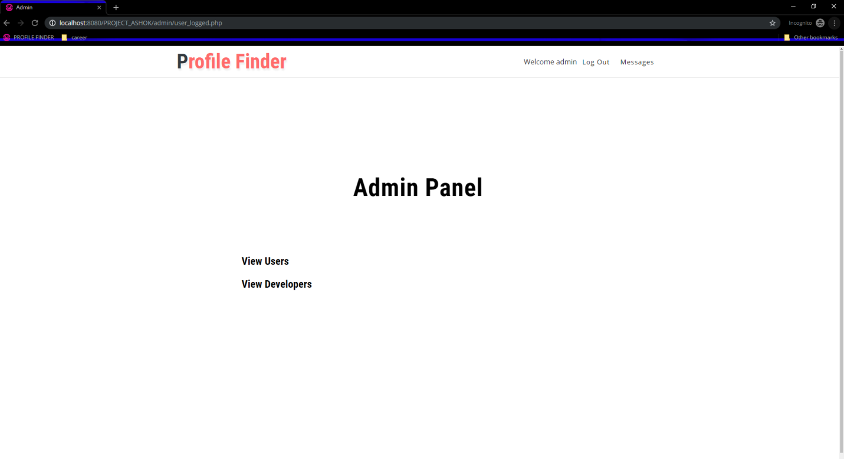

**7.3 OUTPUT DESIGN**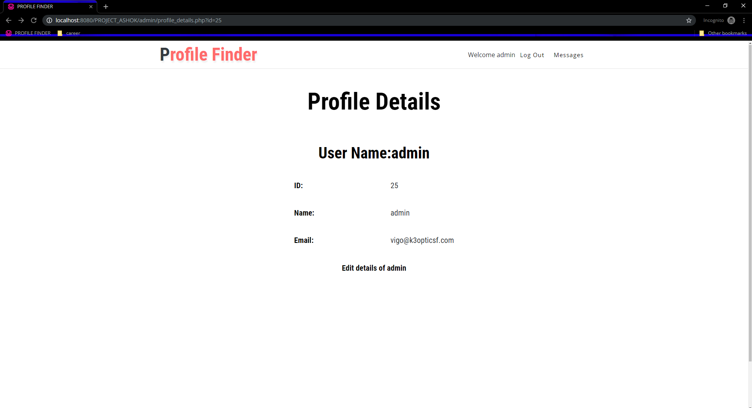

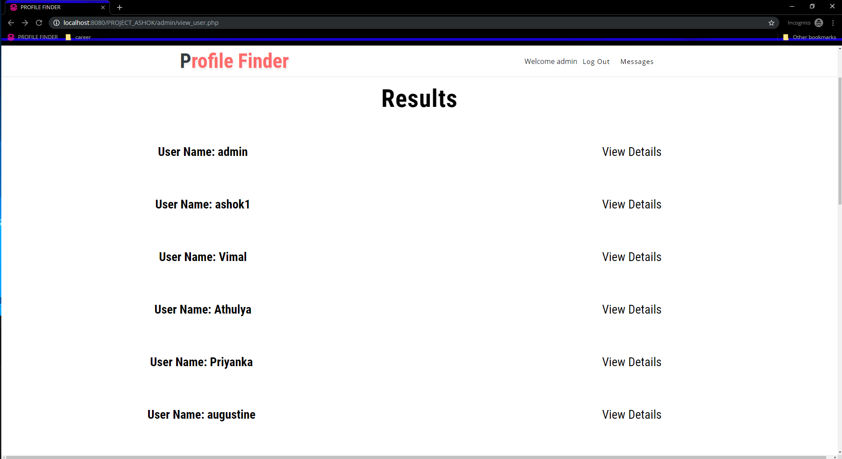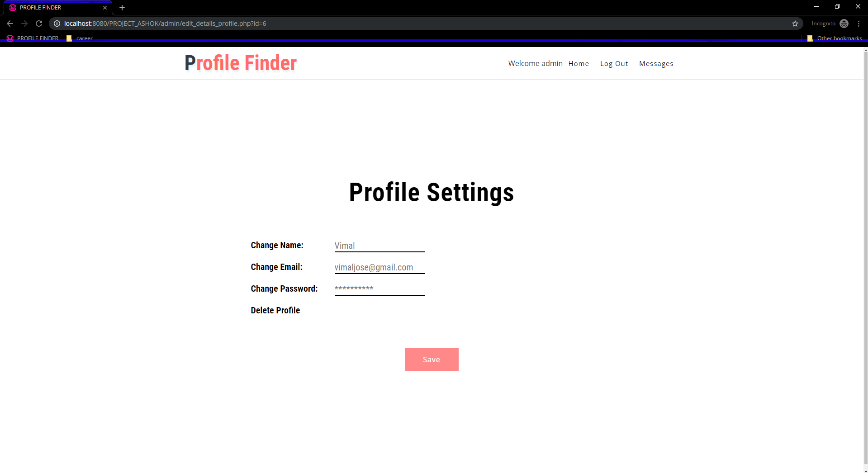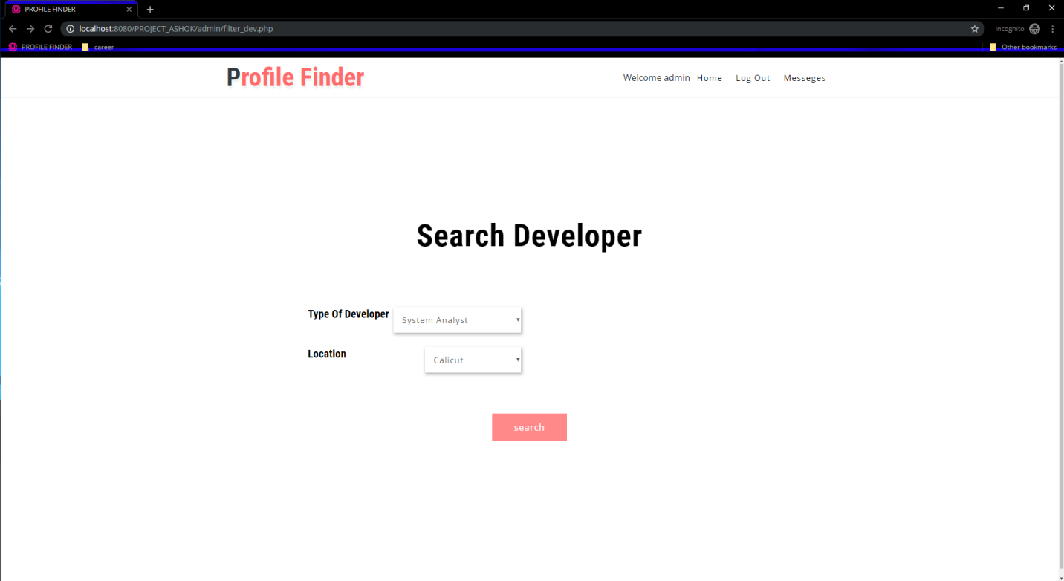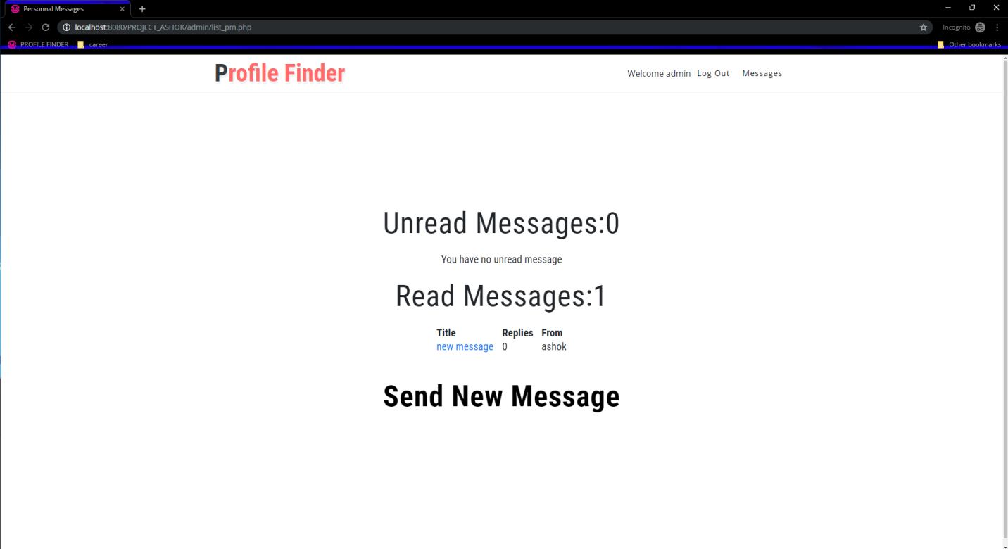

**8. CONCLUSION**

This system is very flexible and changes can be made without much difficulty. The further extension in the system can be made to submit more outputs to the management. The development of the system is based on the ideas that we got during the detailed study of the system.

Since sublime text 3, SQLyog is very flexible on the incorporate any modular program into the application. Thus, even after development phase is over, developing new application and integrating in which the existing one is very easy. This project can be further enhanced by adding more features.

**9. BIBLIOGRAPHY**

References

Website

* google.com
* fontawesome.com
* w3schools.com